Experiment 4 M. Devarajulu
CRIPT-ARITHMATIC 192212058
Aim
To solve Cript-Arithmatic problem using python program
Algorithm
1 Start the program.
2 Import the permutations function from the itertools module.
3 Define the letters used in the cryptarithmetic puzzle (e.g., SEND + MORE = MONEY).
4 Generate all possible permutations of digits (0–9) for the letters.
5 Assign a unique digit to each letter.
6 Check that the leading letters (such as S and M) are not assigned the digit 0.
7 Convert the letters into their corresponding numeric values to form the numbers (e.g., SEND, MORE, and MONEY).
8 Verify whether the equation SEND + MORE = MONEY is satisfied.
9 If the equation is true, display the solution (the values of SEND, MORE, and MONEY) and stop the search.
10 If no valid assignment is found, display "No solution found."
11End the program.

Program
from itertools import permutations

# Letters in the puzzle
letters = ('S', 'E', 'N', 'D', 'M', 'O', 'R', 'Y')

# Try all possible digit assignments
for perm in permutations(range(10), len(letters)):
S, E, N, D, M, O, R, Y = perm

# Leading letters cannot be zero
if S == 0 or M == 0:
continue

# Form the numbers
SEND = 1000*S + 100*E + 10*N + D
MORE = 1000*M + 100*O + 10*R + E
MONEY = 10000*M + 1000*O + 100*N + 10*E + Y

# Check the equation
if SEND + MORE == MONEY:
print("Solution Found!")
print("SEND =", SEND)
print("MORE =", MORE)
print("MONEY =", MONEY)
break

Output
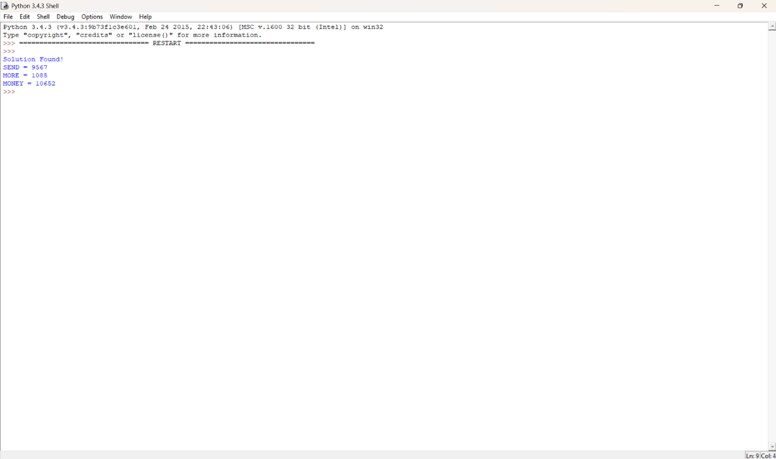

Result
The program successfully finds the unique solution:

